

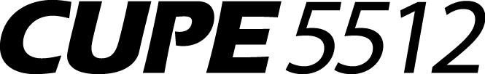

**T0:** All CUPE Local 5512 Members

**FROM:** Dale Smith, President

Dianne Rasmussen, Recording Secretary

**RE: UPDATED** Election 2020 Results

**DATE:** Tuesday, June 9, 2020

As per SECTION 11 of our Local Bylaws, the following nominations were received for the 2020 election:

**President Dale Smith**

**Vice-President (Moose Jaw) Don Chesney**

**Vice-President (North) Kam Gehlen**

**Recording Secretary Dianne Rasmussen**

**Trustee 1-year term VACANT**

**Trustee 3-year term VACANT**

One nomination was received for each of these positions; therefore, a vote will not be necessary. The above members met the criteria set out in the Bylaws and are acclaimed in their positions. CONGRATULATIONS!

Thank you to Wade Hassett for all of his work with CUPE Local #5512.

ALL duly elected officers shall be installed at the General Membership meeting on Saturday, June 20th.

Current Executive Members:

Vice-President (Moose Jaw) Bill Johnston

Vice-President (South) Jackie Dayman

Secretary-Treasurer Melody Stark

Trustee 2-year term Lori Kilkenny